**SQL QUERIES**

use insuranceproject;

# KPI:1 - Number of Invoices by Account Executive:

SELECT 'Account Executive', COUNT (*) AS 'Total No. of Invoices'

FROM invoice;

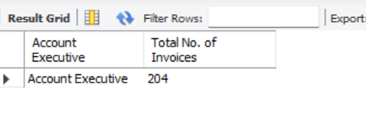

# KPI2: Yearly Meeting Count:

SELECT

YEAR(STR_TO_DATE(meeting_date, '%Y-%m-%d')) AS year,

COUNT(*) AS meeting_count

FROM

meeting

WHERE

meeting_date IS NOT NULL

AND STR_TO_DATE(meeting_date, '%Y-%m-%d') IS NOT NULL

GROUP BY

YEAR(STR_TO_DATE(meeting_date, '%Y-%m-%d'))

ORDER BY

year;

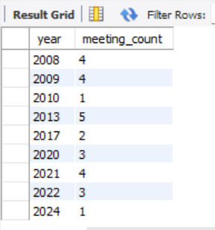

# KPI3.1: Cross Sell--Target, Achive, new

SELECT

'Cross Sell' AS KPI_Type,

COUNT(DISTINCT policy_number) AS Target, -- Count of distinct policies for target

SUM(Amount) AS Achieve, -- Total amount achieved (revenue)

SUM(Amount) - COUNT(DISTINCT policy_number) AS New -- New calculation (difference between target and achieve)

FROM brokerage

WHERE renewal_status = 'Endorsement'; -- Cross Sell policies are typically marked as 'Endorsement'

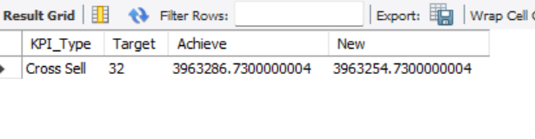

## KPI3.2: New-Target,Achive,new

SELECT

'New' AS KPI_Type,

COUNT(DISTINCT policy_number) AS Target, -- Count of distinct 'New' policies for target

SUM(Amount) AS Achieve, -- Total amount for 'New' policies

SUM(Amount) - COUNT(DISTINCT policy_number) AS New -- New calculation (difference between target and achieve)

FROM brokerage

WHERE renewal_status = 'New'; -- Filter for policies marked as 'New'

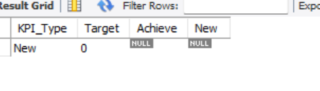

# KPI3.3 Renewal-Target, Achive,new

SELECT

'Renewal' AS KPI_Type,

COUNT(DISTINCT policy_number) AS Target, -- Count of distinct 'Renewal' policies for target

SUM(Amount) AS Achieve, -- Total amount for 'Renewal' policies

SUM(Amount) - COUNT(DISTINCT policy_number) AS New -- New calculation (difference between target and achieve)

FROM brokerage

WHERE renewal_status = 'Renewal'; -- Policies marked as 'Renewal'

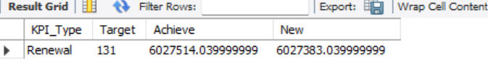

# KPI4: Stage Funnel by Revenue:

SELECT stage, SUM(revenue_amount) AS revenue

FROM opportunity

GROUP BY stage;

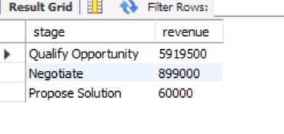

# KPI5: Number of Meetings by Account Executive

SELECT

`Account Executive` AS account_executive,

COUNT(*) AS meeting_count

FROM

meeting

WHERE

`Account Executive` IS NOT NULL

GROUP BY

`Account Executive`

ORDER BY

meeting_count DESC;

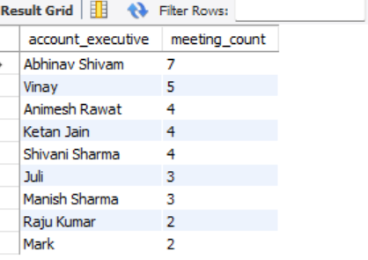

# KPI6: Top Open Opportunity:

SELECT opportunity_name, SUM(revenue_amount) AS 'Top_Opportunity'

FROM opportunity

WHERE stage = 'Qualify Opportunity' OR stage = 'Propose Solution'

GROUP BY opportunity_name

ORDER BY SUM(revenue_amount) DESC

LIMIT 5;

